Airline Ticket Booking and Revenue Analysis Report
Introduction
In order to gain a deeper understanding of the trend of ticket bookings and revenue earned through those bookings, we have utilized a line chart visualization. Upon analysis of the chart, we observe that the number of tickets booked exhibits a gradual increase from June 22nd to July 7th, followed by a relatively stable pattern from July 8th until August, with a noticeable peak in ticket bookings where the highest number of tickets were booked on a single day. It is important to note that the revenue earned by the company from these bookings is closely tied to the number of tickets booked. Therefore, we can see a similar trend in the total revenue earned by the company throughout the analyzed time period. These findings suggest that further exploration of the factors contributing to the peak in ticket bookings may be beneficial for increasing overall revenue and optimizing operational strategies.
- Objectives
The strategic objectives of this analysis are as follows:
- Increase occupancy rate: By increasing the occupancy rate, we can boost the average profit earned per seat and mitigate the impact of the challenges we're facing.
- Improve pricing strategy: We need to develop a pricing strategy that takes into account the changing market conditions and customer preferences to attract and retain customers.
- Enhance customer experience: We need to focus on providing a seamless and convenient experience for our customers, from booking to arrival, to differentiate ourselves in a highly competitive industry and increase customer loyalty.
The end goal of this task would be to identify opportunities to increase the occupancy rate on low-performing flights, which can ultimately lead to increased profitability for the airline.
- Ticket Bookings Trend Analysis
The analysis reveals critical patterns in ticket booking behavior over the June-August 2017 period:
- Growth Phase (June 22 - July 7): A gradual increase in ticket bookings, indicating rising demand
- Stabilization Phase (July 8 - August 15): A relatively consistent booking pattern with minor fluctuations

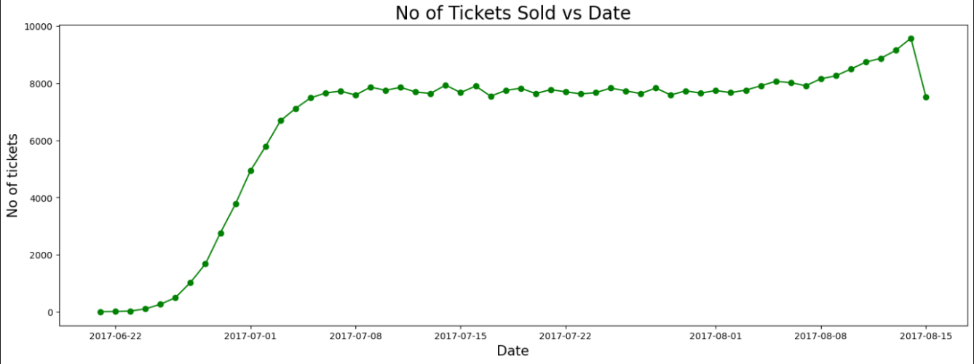

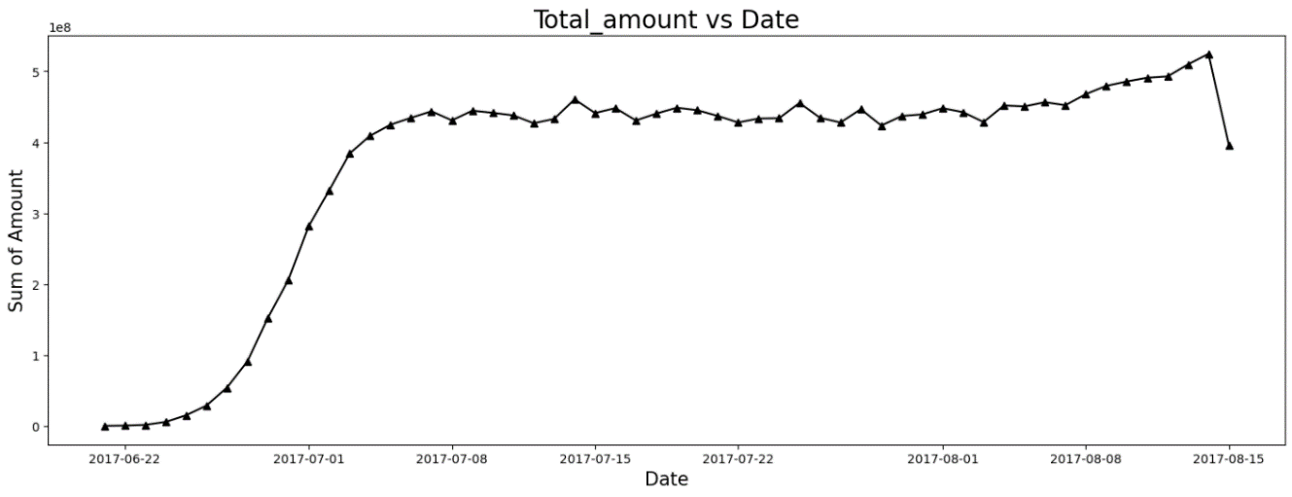
- Peak Period: The highest concentration of bookings occurred during early-to-mid July, suggesting optimal market conditions
- Decline Phase (Mid-August): A noticeable drop in bookings towards the end of the analysis period
The correlation between ticket volume and revenue generation is direct and significant, making booking trends a critical metric for financial forecasting and resource allocation.

Basic Analysis
The basic analysis of data provides insights into the number of planes with more than 100 seats, how the number of tickets booked and total amount earned changed over time, and the average fare for each aircraft with different fare conditions. These findings will be useful in developing strategies to increase occupancy rates and optimize pricing for each aircraft.
- Aircraft Fleet Analysis
Table 1 presents aircraft with more than 100 seats and their seat capacity:
Aircraft Code | Number of Seats
319 | 116
320 | 140
321 | 170
733 | 130
763 | 222
773 | 402

Key Insights: The aircraft fleet ranges from 116 to 402 seats, with the 773 being the largest capacity aircraft. These larger aircraft are critical for revenue optimization strategies.
- Fare Conditions Analysis
The analysis of average costs across different fare conditions for each aircraft reveals important pricing patterns. When different pricing circumstances within each aircraft are compared, the charges for business class are consistently greater than those for economy class. This trend may be seen across all planes, regardless of fare conditions.
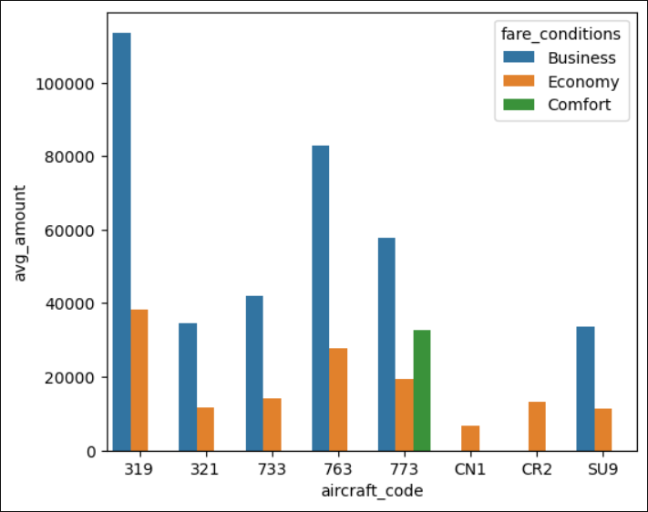
- Business vs. Economy Class: Business class consistently commands premium pricing, with significantly higher average revenue per seat compared to economy fares.
- Comfort Class Availability: The comfort class is available on only one aircraft (the 773). The CN1 and CR2 planes, on the other hand, only provide the economy class. This segmentation strategy allows for differentiated pricing and market targeting.

- Occupancy Rate Analysis
Higher occupancy rates indicate that aircraft seats are more booked with fewer unbooked seats. This metric is essential for understanding fleet utilization efficiency.
Aircraft Occupancy Metrics
Aircraft Code | Booked Seats | Total Seats | Occupancy Rate
319 | 53.58 | 116 | 46.19%
321 | 88.81 | 170 | 52.24%
733 | 80.26 | 130 | 61.73%
763 | 113.94 | 222 | 51.32%
773 | 264.93 | 402 | 65.90%
CN1 | 6.00 | 12 | 50.04%
CR2 | 21.48 | 50 | 42.97%
SU9 | 56.81 | 97 | 58.57%

Occupancy Rate Insights:
- Aircraft 773 demonstrates the highest occupancy rate at 65.90%, indicating strong seat utilization despite being the largest aircraft
- Aircraft 733 achieves 61.73% occupancy, the second-highest rate, showing effective capacity utilization
- Aircraft 319 shows the lowest occupancy rate at 46.19%, indicating potential for improvement in seat utilization
- Aircraft CR2 has a 42.97% occupancy rate, the lowest among larger aircraft, suggesting opportunities for optimization

- Strategic Implications
High-Performing Aircraft
Aircraft with higher occupancy rates (773 at 65.90%, 733 at 61.73%) demonstrate strong market demand and effective operational efficiency. These aircraft should be prioritized for high-demand routes during peak periods.
Optimization Opportunities
Aircraft with lower occupancy rates (CR2 at 42.97%, 319 at 46.19%) present significant opportunities for improvement:
- Pricing Strategy Adjustment: Dynamic pricing during peak demand periods could increase seat bookings
- Route Optimization: Reassessing route assignments to better match passenger demand
- Marketing Focus: Targeted promotional campaigns to fill vacant seats
- Schedule Adjustment: Modifying flight schedules to align with customer travel patterns
- Revenue Impact of Occupancy Rate Improvements
Airlines can assess the potential financial impact of increasing occupancy rates. Even modest improvements in occupancy can yield significant revenue gains:
- 10% Occupancy Increase: Airlines can project how total revenue would increase if occupancy rates improved by 10% across the fleet
- Realistic Strategy: This research demonstrates the financial benefits of boosting occupancy rates, helping airlines determine if raising occupancy is a practical and worthwhile strategy
- Pricing Focus: Results indicate that occupancy improvements develop gradually, suggesting airlines should prioritize pricing strategies alongside occupancy initiatives
- Conclusion
Occupancy rate analysis reveals critical insights into aircraft utilization and revenue generation efficiency. While some aircraft (773, 733) demonstrate strong occupancy performance, others (CR2, 319) indicate significant optimization opportunities. By implementing data-driven strategies focused on pricing optimization, route planning, and enhanced customer experience, the airline can improve overall occupancy rates and maximize profitability across its fleet.
The occupancy metrics provide a foundation for strategic decision-making in fleet management, route allocation, and pricing strategies. Sustained focus on improving occupancy rates, combined with dynamic pricing approaches, will ensure continued revenue growth and operational excellence.

